GLASS HALO
Magnetoplasma Stand-Off Shield Architecture
Proof-of-Concept White Paper
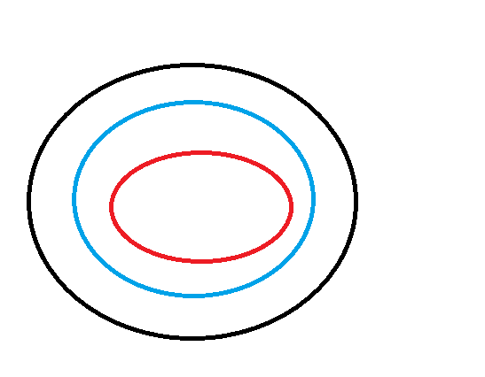
Concept Thesis
Glass Halo proposes a layered stand-off shield in which an inner confinement field and an outer shaping field maintain a controlled plasma shell around a spacecraft, creating an active interaction veil for charged radiation, plasma exposure, and selected directed-energy threats.

1. Abstract
Glass Halo is a speculative defensive architecture for deep-space vehicles that combines magnetic field shaping, confined plasma, and layered hull shielding into a single stand-off protection envelope. The inner field stabilizes plasma behavior near the vessel, while a stronger outer field establishes stand-off distance and interaction geometry. Between the two, a managed plasma shell acts as a sacrificial veil that can deflect, bloom, scatter, or absorb part of incoming charged particle flux before it reaches structural mass. The concept is not framed as an invincible force field; it is instead a controllable reduction layer intended to lower radiation load, soften plasma impacts, and degrade selected energy threats.
2. Design Intent
The design intent behind Glass Halo is to create a shipboard shield system that behaves more like a living buffer than a static wall. The architecture is especially suited to spacecraft already carrying high-energy systems, field-control hardware, cryogenic infrastructure, or reactor-linked synchronization logic. Within the broader GhostCore family, Glass Halo functions as a defensive boundary system rather than a propulsion core. Its main role is to hold danger away from the hull, preserve field coherence around the vessel, and provide time for the ship’s structural shielding and internal control systems to do their work.
3. Architectural Layers
Layer | Primary Function | Candidate Hardware | Notes
Inner Confinement Field | Stabilizes local plasma behavior and prevents collapse into the hull envelope. | Superconducting coils, field regulators, plasma diagnostics | Closest to the vessel and tuned for control, not long-range interception.
Plasma Veil | Acts as the active interaction medium for charged radiation and plasma contact. | Ionized noble-gas or seeded plasma layer | Best understood as a sacrificial buffer that can be replenished.
Outer Shaping Field | Sets stand-off geometry, expands interaction zone, and biases incoming charged flow. | Higher-power coil ring, pulse drivers, envelope control loops | Provides distance and steering influence, but requires significant power.
Structural Shield Layer | Catches what still gets through and protects crew spaces and critical systems. | Water tanks, hydrogen-rich composites, thermal tiles, hull armor | Essential for neutrons, gamma exposure, and residual energy.

4. Operating Principle
In the proposed geometry, the inner and outer fields do not function as simple positive and negative magnetic shells. A better engineering interpretation is that the inner layer handles confinement and stability, while the outer layer shapes the interaction boundary and establishes stand-off distance. Plasma is retained and regulated between these field domains. Incoming charged particles encounter the outer field first, are bent or slowed, and then interact with the plasma shell. That interaction can redirect some flux, spread out energy deposition, and reduce the sharpness of the event before the residual load reaches the hull.
Against interstellar and solar radiation, the concept is strongest against charged particle populations rather than neutral or ultra-high-energy backgrounds. Against directed-energy threats, it is best treated as a degradation layer: it may scatter or bloom selected beams, interfere with ion or plasma streams, and convert part of the interaction into heat and turbulence that can then be managed by downstream systems. It is not expected to stop every threat class outright.
5. Mission Utility
• Charged-particle radiation reduction for deep-space cruise and solar storm exposure.
• Stand-off plasma management around high-energy reactor or propulsion operations.
• Degradation of selected beam or plasma-based threats before hull contact.
• Thermal spreading and controlled energy dumping into secondary shield systems.
• Potential integration with synchronized utility, propulsion, or defensive control stacks.
6. Control and Integration
Glass Halo benefits from the same synchronization logic already present in Mercy-style coupling systems and Halo-family infrastructure concepts. A central coordination layer can regulate coil timing, plasma density, replenishment cycles, and threat-mode transitions. This means the shield can shift between cruise mode, storm mode, and defensive interception mode rather than remaining in a single static state. In practical terms, the synchronization stack becomes the shield’s nervous system.
This also opens the door to shared interfaces with thermal recovery systems, superconducting power spines, and regenerative veil concepts such as Seraphim-style overload capture. A mature implementation would likely treat Glass Halo not as an isolated module, but as one defensive organ in a larger ship-scale architecture.
7. Known Limits and Physical Boundaries
Threat Class | Expected Benefit | Boundary / Limitation
Solar wind / charged particles | Strongest case | Most plausible use of field-plus-plasma shielding.
Solar energetic particle events | Moderate reduction | Helpful, but still needs mass shielding and storm shelters.
Galactic cosmic rays | Limited reduction | Very high energies make full deflection difficult.
Gamma / neutron radiation | Minimal direct benefit | Requires mass shielding and specialized absorbers.
Charged particle or plasma weapon | Potential degradation | Depends on power density, duration, and stand-off distance.
High-power laser | Possible blooming or scattering | Short-pulse or overwhelming beam energy may still punch through.

8. Bench-Scale PoC Roadmap
Phase 1 — Field Simulation: Model nested coil geometry, plasma retention volume, stand-off distance, and heat deposition across representative threat types.
Phase 2 — Vacuum Chamber Trial: Demonstrate stable plasma retention between two controlled field layers in a small vacuum vessel using a benign noble-gas fill.
Phase 3 — Particle Interaction Test: Expose the plasma veil to low-energy charged particle streams and compare dose/load at the sensor plane with and without the field shell.
Phase 4 — Beam Degradation Trial: Assess whether the plasma layer produces measurable blooming, scattering, or attenuation for controlled optical or plasma exposure.
Phase 5 — Integrated Control Test: Tie field timing, plasma density, and thermal rejection into a synchronization controller and test mode transitions under disturbance.
9. Key Measurements
– plasma retention stability and replenishment rate
– stand-off distance achieved at given power levels
– reduction in charged-particle dose at the inner sensor layer
– beam blooming / scattering signatures under controlled exposure
– thermal load captured by downstream shield and recovery systems
– control-loop response time during rapid mode changes
10. Conclusion
Glass Halo is a coherent speculative extension of existing magnetoplasma and stand-off shielding ideas. Its value lies in combining several partial defenses into a managed envelope: magnetic shaping for charged-particle steering, plasma as an active sacrificial interaction medium, and structural shielding as the final absorber. In this sense, Glass Halo is not a fantasy wall but a layered reduction strategy.
Within the GhostCore family, it reads cleanly as a boundary system: the outer field keeps danger at arm’s length, the inner field keeps the veil from collapsing into chaos, and the ship’s mass shielding catches what the halo cannot deny. That combination gives the concept both poetic identity and a practical PoC path.
Appendix A. Naming Rationale
Glass Halo
The name reflects the system’s intended behavior: a hard-to-see stand-off veil, elegant in shape, dangerous at its boundary, and transparent enough that it is never mistaken for invulnerability.

